**Quick Start Guide**

1. Start the local server using Apache

2. Execute the Mainpage.php and navigate using the given links

**Main Page**

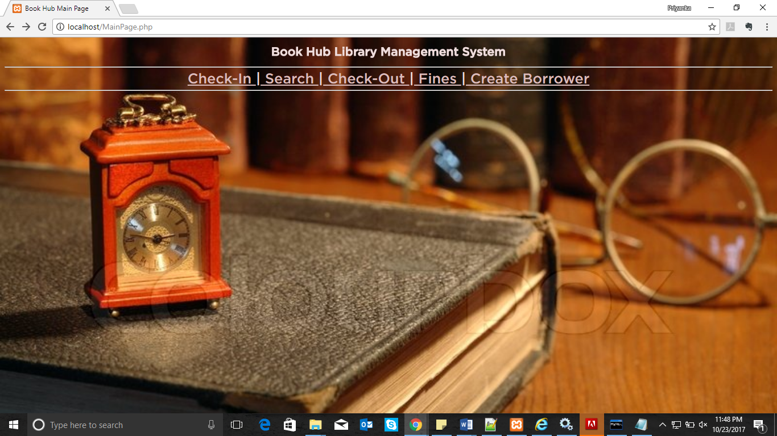

**Search Page**

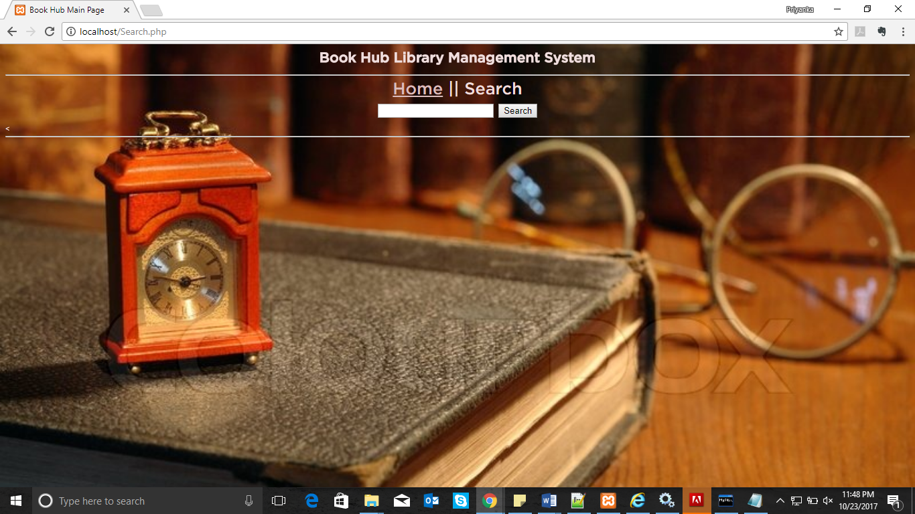

Enter the ISBN or book title or author’s name

**Create Borrower**

Enter the required fields and click to proceed.

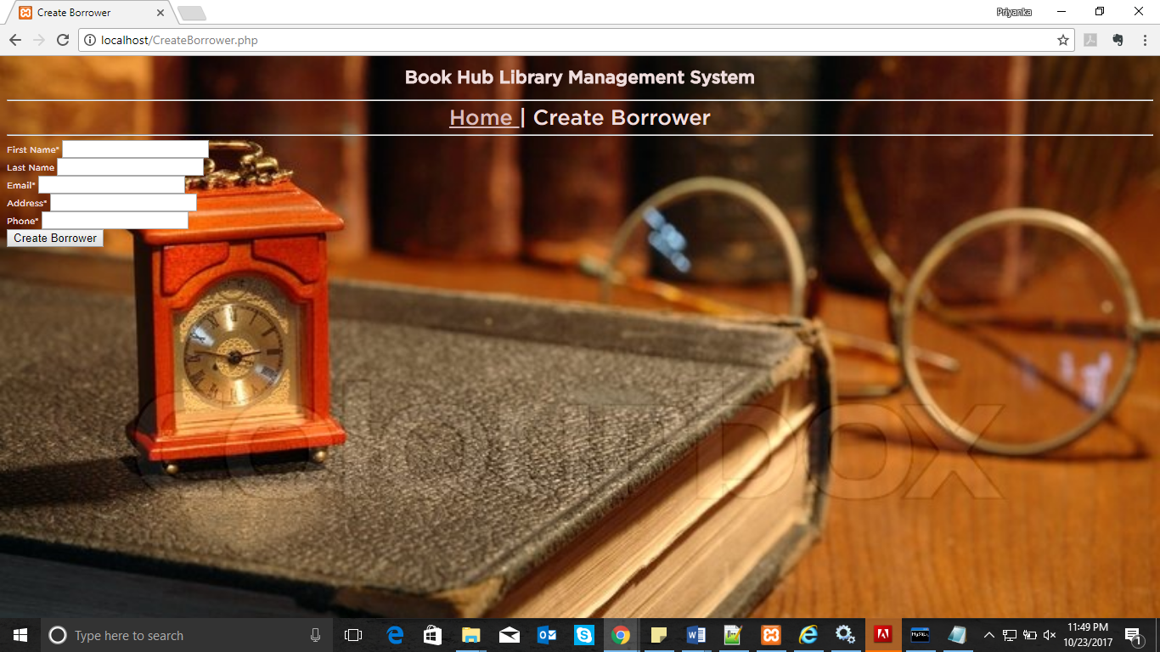

**Check In**

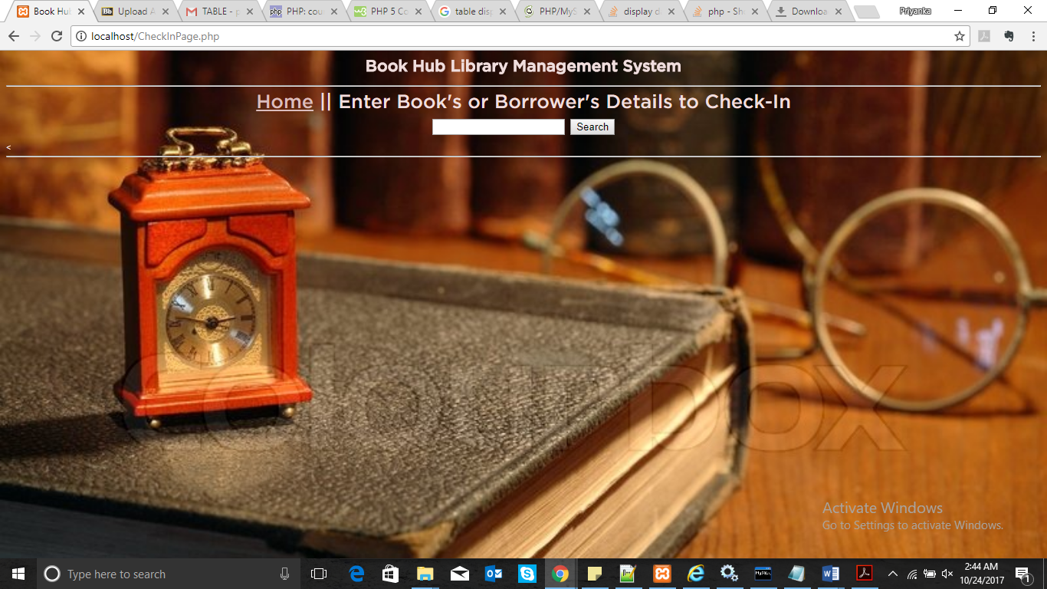

**Check In the book by entering card id or borrower’s name or isbn**

**CheckOut**

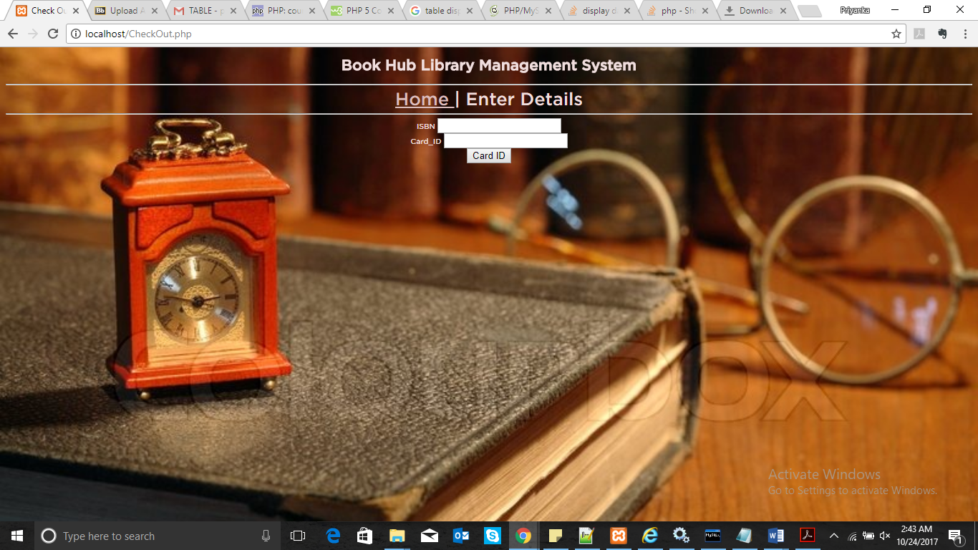

**Enter the card id and ISBN to check out a book**

**To check out the selected book**

**Fines**

**Refresh all the table values by clicking the refresh button or check individual history or current fines by giving the card number.**